TELCO CUSTOMER
RETENTION ANALYSIS

Churn Patterns • Retention Drivers • Strategic Recommendations

Based on 7,043 Customer Records
Prepared for Executive & Product Leadership

Executive Summary
This report analyses churn and retention patterns across 7,043 telco subscribers. With a current churn rate of 26.5%, the business loses approximately $139,131 in monthly recurring revenue. Churned customers generate 40% less lifetime value than retained ones. Immediate action on three high-leverage levers — contract length, internet service quality, and payment method — can realistically reduce churn below 18% within 12 months.

26.5%  Overall Churn Rate | $139K  Monthly Revenue at Risk | $1,532  Avg CLV (Churned) | $2,550  Avg CLV (Retained)

Key finding: customers who churn have an average tenure of just 18 months vs. 38 months for those who stay — a gap that reveals a critical window of vulnerability in the first two years.

1. Churn Patterns

1.1 Churn by Contract Type
Contract type is the single strongest predictor of churn. Month-to-month customers churn at 42.7% — over 15x the rate of two-year contract holders (2.8%). This is the #1 lever available to the business.

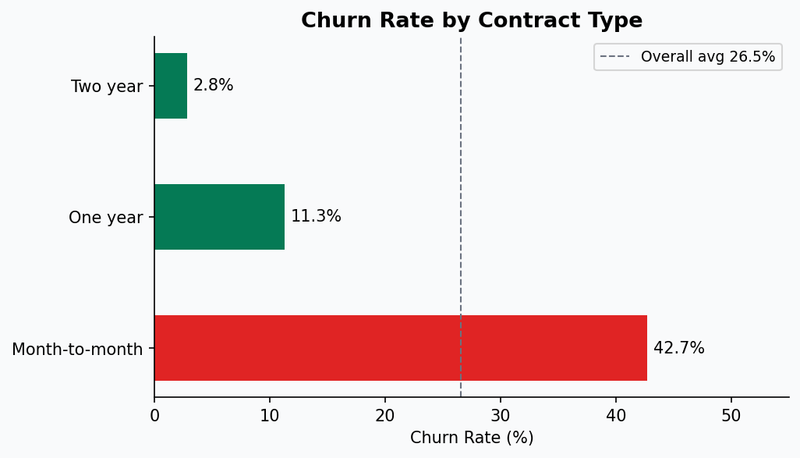

Contract Type | Churn Rate | Risk Level
Month-to-month | 42.7% | 🔴 Critical
One year | 11.3% | 🟡 Moderate
Two year | 2.8% | 🟢 Low

1.2 Churn by Customer Tenure
Churn is heavily front-loaded. More than half of new customers (0–6 months) churn before they become profitable. The rate drops sharply after the first year, and falls to ~12% for customers past the 3-year mark. This underscores the critical importance of early-lifecycle retention programmes.

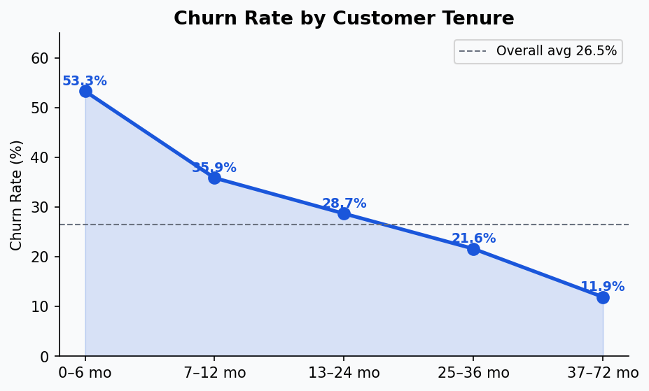

Tenure Band | Churn Rate | Observation
0–6 months | 53.3% | Critical drop-off window
7–12 months | 35.9% | Still elevated – needs nurturing
13–24 months | 28.7% | Approaching average
25–36 months | 21.6% | Stabilising
37–72 months | 11.9% | Loyal base – protect carefully

1.3 Churn by Internet Service
Fibre optic customers churn at 41.9% — more than twice the DSL rate (19.0%). This strongly suggests a perceived value gap: customers paying a premium for fibre are not feeling the corresponding benefit, possibly due to reliability, speed consistency, or support quality.

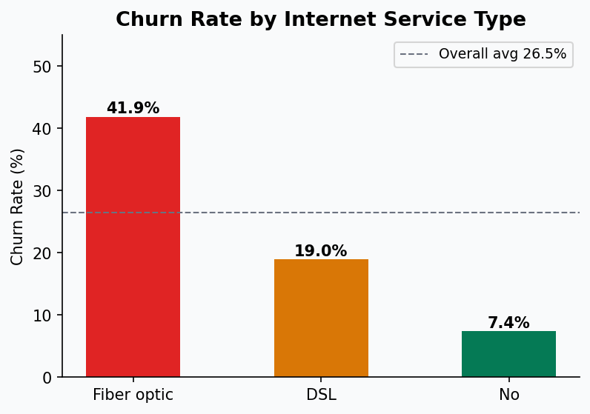

1.4 Churn by Payment Method
Electronic cheque users churn at a staggering 45.3% — nearly 3× the rate of automatic payment customers (~16%). Manual payment methods correlate strongly with disengagement and at-risk status. Customers on automatic billing are significantly more 'sticky'.

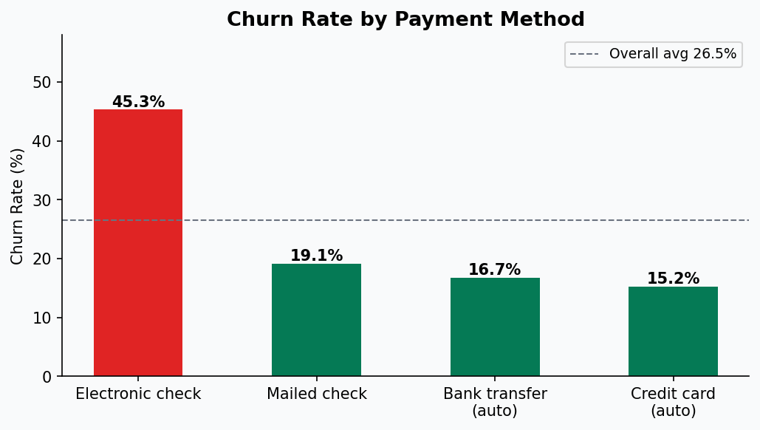

2. Retention Drivers

2.1 Value-Added Services
Customers with Online Security or Tech Support churn at only 14–15%, compared to 42% for internet customers with no add-ons. These services act as powerful 'hooks' that increase switching costs and perceived value. Upselling these to at-risk segments should be a top priority.

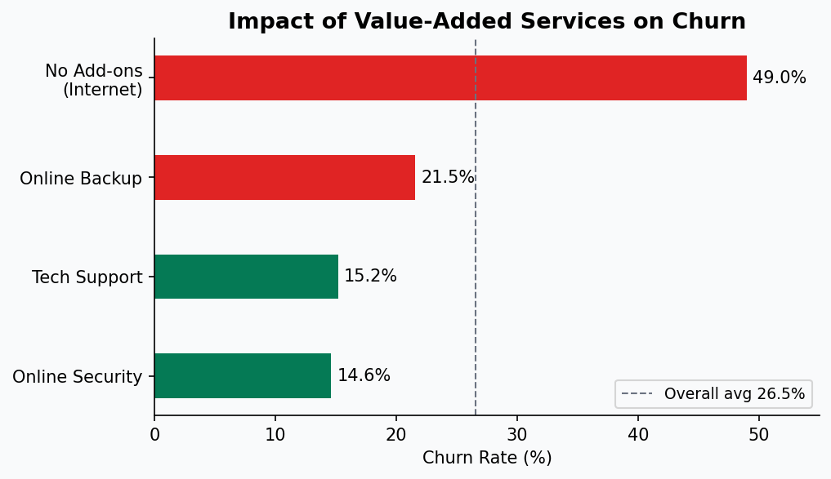

Service | Churn Rate | vs. No Add-on
Online Security | 14.6% | ↓ 27 pp lower
Tech Support | 15.2% | ↓ 26 pp lower
Online Backup | 21.5% | ↓ 18 pp lower
No Add-ons (Internet) | 42.0% | Baseline risk

2.2 Monthly Charges & Price Sensitivity
Churned customers pay on average $74.44/month vs $61.27 for retained customers. This counterintuitive finding reflects the composition effect: churners are disproportionately month-to-month fibre customers paying high rates without receiving matched value. Price is not the root cause — value perception is.

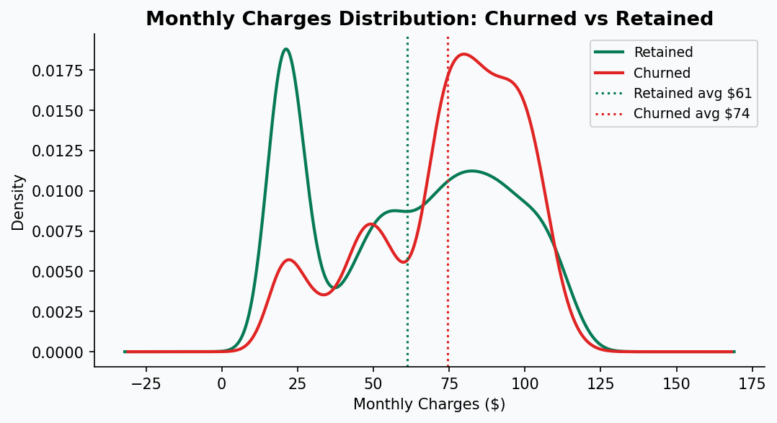

2.3 Demographic Retention Factors
Customers with a partner churn at 19.7% vs. 33.0% for those without. Customers with dependents churn at just 15.5% vs. 31.3% for those without. Senior citizens churn at 41.7% vs. 23.6% for non-seniors. These patterns suggest that life-stage targeting (family plans, senior support programmes) can materially improve retention.

Segment | Churn Rate | Insight
Has partner | 19.7% | Lower risk — anchor in household
No partner | 33.0% | Higher risk — more mobile
Has dependents | 15.5% | Lowest risk — sticky household
No dependents | 31.3% | Elevated risk
Senior citizen | 41.7% | High risk — may need dedicated support
Non-senior | 23.6% | Near-average risk

3. High-Risk Customer Segments

3.1 Segment Heatmap
The intersection of contract type and internet service reveals the highest-risk pockets. Month-to-month fibre customers represent a particularly acute risk, with churn rates exceeding 50% in some sub-segments.

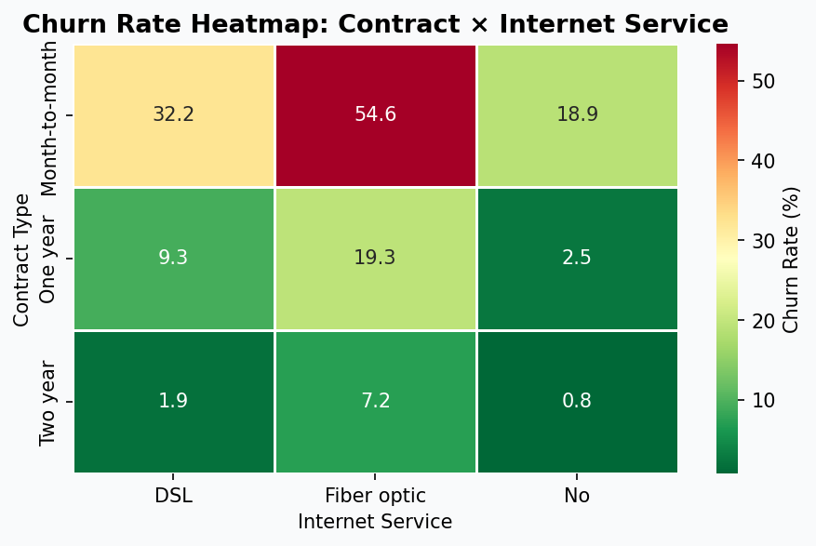

3.2 Priority Risk Segments
The following four segments have been identified as highest priority for retention intervention:

Segment | Customers | Churn Rate | Priority
Month-to-month + Fibre + E-check | 1,307 | 60.4% | P0 – Immediate
Month-to-month + No security | 2,631 | 51.0% | P0 – Immediate
Senior citizens, month-to-month | 807 | 54.6% | P1 – High
Tenure < 6 months | 1,481 | 52.9% | P1 – High

These four segments together represent 6,226 customers — nearly 90% of the total at-risk population — and collectively generate the bulk of monthly revenue loss.

4. Strategic Recommendations

Priority 1 — Contract Conversion Campaign
Objective: Move month-to-month customers to annual or two-year contracts.
- Offer a 10–15% discount incentive for customers who upgrade to a 1- or 2-year term within their first 90 days.
- Target the 1,307-strong P0 segment (Fibre + E-check + month-to-month) with a dedicated outbound outreach campaign.
- Frame the offer around price certainty and exclusive features, not just cost.
- Expected impact: Moving 20% of month-to-month customers to annual contracts could reduce overall churn rate by ~5 percentage points.

Priority 2 — Early-Lifecycle Onboarding Programme
Objective: Reduce the 53% churn rate in the 0–6 month window.
- Implement a structured 90-day welcome journey: welcome call at day 7, check-in at day 30, loyalty offer at day 60.
- Proactively offer Online Security and Tech Support trials to new customers — convert to paid at day 60.
- Assign a customer success touchpoint for all fibre customers in their first 6 months.
- Expected impact: A 15% reduction in early-tenure churn would save approximately 110 customers per month.

Priority 3 — Add-On Upsell to At-Risk Customers
Objective: Drive adoption of Online Security and Tech Support among high-churn internet customers.
- Identify all internet customers without Online Security or Tech Support — 2,631 customers at 51% churn risk.
- Launch a 3-month bundled trial of both services at no extra cost, then offer a discounted bundle rate.
- Automate in-app prompts and email nudges for customers who have never activated these features.
- Expected impact: If 30% of unprotected customers adopt add-ons, churn in this segment could fall from 51% to ~28%.

Priority 4 — Payment Method Migration
Objective: Shift electronic cheque users to automatic payment methods.
- Offer a $5/month bill credit for customers who switch to automatic bank transfer or credit card payment.
- Simplify the in-app process for switching payment methods to a single click.
- Include a payment-method prompt in the new customer onboarding flow to prevent customers defaulting to e-cheque.
- Expected impact: E-cheque customers moving to auto-pay would see churn rates drop from 45% to ~16%.

Priority 5 — Fibre Quality & Perceived Value Programme
Objective: Reduce the 41.9% churn among fibre customers by addressing the value gap.
- Conduct a NPS/CSAT survey specifically for fibre customers to diagnose specific pain points (speed, reliability, support).
- Create a 'Fibre Loyalty' tier with speed guarantees, priority support, and exclusive streaming bundles.
- Proactively communicate service improvements and usage statistics to reinforce perceived value.
- Expected impact: Aligning perceived value with price could reduce fibre churn from 42% to below 25%.

5. Implementation Roadmap

Timeline | Initiative | Owner | KPI Target
Month 1–2 | Launch P0 contract conversion outreach | Sales / CRM | 20% of P0 segment converted
Month 1–3 | Deploy 90-day onboarding journey | Product / CS | 0–6mo churn < 40%
Month 2–4 | Add-on trial programme (Security + TechSupport) | Marketing | 30% trial adoption
Month 2–3 | Payment method migration campaign | Billing / Product | E-cheque users drop by 25%
Month 3–6 | Fibre quality survey & Loyalty tier launch | Product / Ops | Fibre churn < 30%
Month 6–12 | Measure, iterate, expand to senior segment | Analytics / CS | Overall churn < 20%

6. Closing Observations

This analysis demonstrates that Telco's 26.5% churn rate is not driven by a single cause — it is the compound effect of contract structure, service quality perception, payment friction, and lifecycle neglect. The good news: every driver identified has a clear, actionable countermeasure.

The highest-ROI interventions are:
- Contract conversion for month-to-month customers (single biggest lever).
- Early-lifecycle onboarding (prevents the most preventable churn).
- Add-on upsell to unprotected internet customers (high volume, high impact).

If three of the five recommendations above are executed with discipline, a realistic 12-month target is to reduce overall churn from 26.5% to below 18%, recovering over $50,000 in monthly recurring revenue and significantly improving customer lifetime value across all cohorts.

This report should be reviewed quarterly as new cohort data becomes available and intervention outcomes can be measured.

